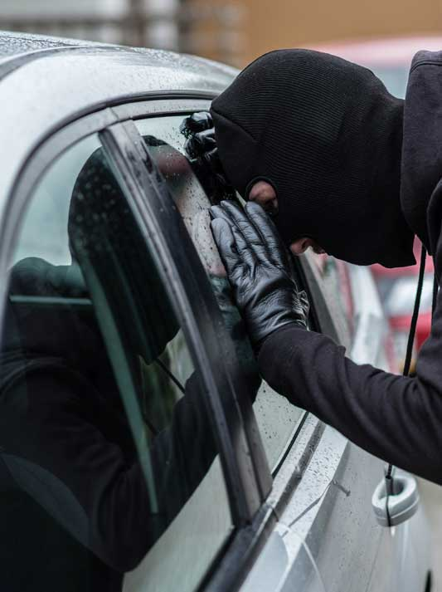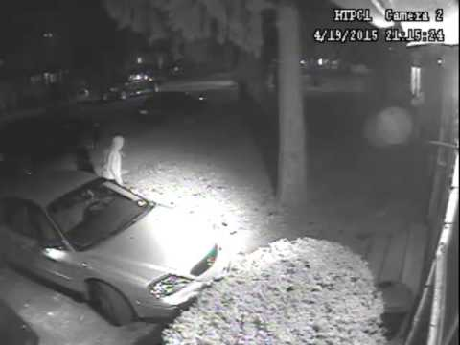
The problem
The number of car stolen is rising. In the UK around 117,000 cars are stolen, with under half of this number ever being recovered.
Thieves will go to all sorts of measures to steal cars, from high-tech computerised methods where they can access cars without the keys, to car key burglary and more primitive measures of breaking windows or using coat hangers and hot wiring cars.

Measures people will go to keeping their cars safe
People will now go to extraordinary measures to keep their cars safe. This includes; fitting ghost programmes (research this on google), fitting steering locks, hiding car keys behind walls to stop computers from picking up the key signal, fitting bollards to their drives and even fitting CCTV and security lights.

Your task today
Write an advice column (around 1 side of A4) advising people about the issue or car theft and what they can do to keep their pride and joy safe.

